**Revitalizing Plastics Recycling, I-Hotel, Champaign IL, September 12, 2017. SPEAKER BIOS & PICTURES**

**Max Babits**, Project Analyst, RRS

*Materials Recovery for the Future*

Max Babits is a Project Analyst at RRS supporting the Materials Recovery for the Future Collaborative. He assisted in MRF testing and data analysis of flexible packaging at IMS recycling services in San Diego and EMTERRA recycling in Vancouver BC. Max is involved in economic studies of recyclable commodities both for RRS and external clients including MRFs, Municipalities and Non-Profits. He has worked on studies that illustrate marketplace volatility and its relationship to other variables and analysis of commodity composition and their value in the recycling stream. Max’s degree is in mechanical engineering from Eastern Michigan University.

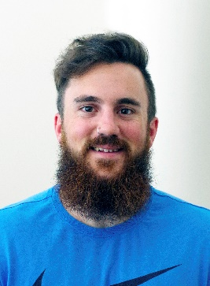**Brian Plotner**, University of Illinois Student Majoring in Public Health

*Plastics Recycling in Illinois, Research Study*

Brian Plotner is a second year master of public health (MPH) student focusing on environmental health and behavior change at the University of Illinois at Urbana-Champaign. As an undergraduate student he received his BS in Kinesiology before deciding to pursue something a little different for graduate school which led him to the MPH program. With this degree he plans to positively impact the health of others by improving the environment as well as helping to develop policies that can improve public health.

This research study was completed with Illinois Sustainable Technology Center as part of the practicum project for an MPH degree. An anonymous online survey that was designed and sent to recycling organizations around the state of Illinois to gain insight into plastics recycling patterns in the state and what some of the barriers may be.

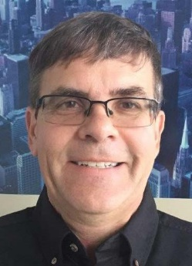**Ken Santowski**, President, Chicago Logistic Service

*Recovering Polystyrene (Styrofoam)*

**Ken Santowski** has been waging a personal & professional war against expanded polystyrene (Styrofoam) waste since 1990. He is president of Chicago Logistic Service which he cofounded in 1996. His company recycles all electronics (including televisions), clothing, packing peanuts, bubble wrap, EPS#4, most plastics, batteries & light bulbs. CLS also annually diverts more than 20 trailer loads of Styrofoam headed for the landfill. It recently developed a partnership with Dart Container Corporation with the goal of establishing drop off sites throughout McHenry and Kane Counties. CLS maintains a 24-hour Styrofoam recycle bin at offices in Elgin that is open to the public.

Polypropylene, polyethylene, poly vinyl chloride, polystyrene, poly unsaturated, Polly want a cracker? So many poly’s and you don’t know what is which one. What’s the difference between #6 plastic and #6 Styrofoam? It’s all so confusing for even the most dedicated recycler. Since 1940 when Dow Chemical employee Ray McIntyre invented Styrofoam (trademark name) the world has come to depend on this amazing product that is so versatile one wonders how we can survive without it. Styrofoam is expanded (not extruded) polystyrene #6. Still confused? Try sorting and recycling these items. Styrofoam will last forever so we need to figure out how to keep it out of the landfill, keep it out of the oceans and prepare it for its own end of life. Whether we realize it or not we prepare for the end of life in every thought and every movement we do.

**DR BK Sharma**, Senior Research Scientist, University of Illinois ISTC

*Fuels from Waste Through Thermochemical Conversions*

BK Sharma is a Senior Research Scientist at the Illinois Sustainable Technology Center, a division of the Prairie Research Institute, University of Illinois at Urbana-Champaign (UIUC). He is also a faculty member in the Dept of Agricultural and Biological Engineering at UIUC and an Adjunct Professor of Energy and Environmental Systems at NCAT State University NC. He is a fellow of the Society of Tribology & Lubrication Engineers. His areas of interests are: thermochemical conversion of biomass and waste material to crude oils; bio-oil upgradation to refinery ready crude oils; recovery of value-added products from bio-oils, such as antioxidants; chemical characterization of petro- and bio- asphalt binders; polymer recovery from waste electronics; and bio-based lubricants and additives.

A large quantity of carbon-containing materials such as waste plastic, used tires, food waste and biomass ends up in landfills. These materials represent a rich energy source that is currently untapped or underutilized. This talk will discuss pyrolysis of non-recyclable plastics to plastic crude oil followed by its distillation to produce gasoline, diesel #1, diesel #2 and vacuum gas oil-like fractions. The analysis of diesel fractions revealed that the Diesel #2 is similar to petro-diesel, meets all fuel specifications after addition of antioxidants, has high energy content and is a suitable substitute or blend component for petro-diesel.

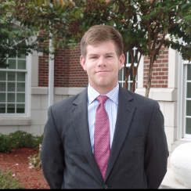**Tanner Smith,** Corporate Development Analyst,Delta Plastics

*Supporting Sustainable Domestic Ag Plastic Recycling*

Tanner Smith graduated with a degree in Economics and a degree in Spanish from the University of Central Arkansas where he worked for the Arkansas Center for Research in Economics.  Passionate about empirical work and problem solving, he began his career at Delta Plastics whose growth-minded and energetic work environment proved to be a perfect match for his desire for challenge and innovation.  In his free time Tanner loves to spend time outdoors with his wife, Whitney, and his friends and family.  Tanner is grateful to be working on the leading edge of the plastic recycling industry and looks forward to a career promoting sustainability.